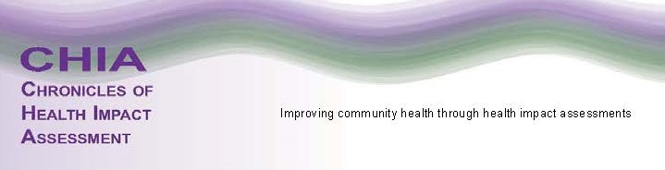

Call for Chronicles of Health Impact Assessment (CHIA) Peer Reviewers
We appreciate your interest in supporting the CHIA journal as a peer reviewer. In this role, you will be asked to read submitted articles. If you do not have time you can decline the invitation to review and will be placed back in the rotation for future opportunities. If you do have time, your review will address the following:

You will submit a written critique that will help determine if the article will be published. You will be asked if you have any conflicts of interest in reviewing an article. All your comments will be anonymous to the authors. You will be given prompts to respond to, such as: what are the article strengths or weaknesses, is this information that is new to the field or building on already known material? All comments should be viewed as constructive criticism for the authors. You will have the choice to accept, recommend acceptance with revisions, or not accept the article.

If you are interested, the following information will assist us in matching peer reviewers to specific authors.
Name |  | E-mail Address
Affiliation |  | Phone Number
Area of HIA Expertise (check all that apply):
 | Agriculture |  | Criminal Justice |  | Health Equity |  | Housing
 | Built Environment |  | Economics |  | HIA Evaluation |  | Labor Policy
 | Climate Change |  | Education |  | HIA Methodology |  | Natural Resources
 | Community Development |  | Energy |  | HIA Theory |  | Redevelopment
 | Transportation |  | Other: ____________________________________________________________
How are you qualified (papers written, journal reviewed for etc)?

